**Graph Isomorphic**

**A. Isomorphic**

Two **graphs** are said to be **isomorphic** if they both satisfy the following conditions:

1. If both **graphs** have same number of vertices(V).
2. If both **graphs** have same number of edges(E).
3. Equal number of vertices with same degrees.
4. Their edge connectivity is retained.

**Note** − In short, out of the two isomorphic graphs, one is a tweaked version of the other. An unlabelled graph also can be thought of as an isomorphic graph.

There exists a function ‘f’ from vertices of G1 to vertices of G2

[f: V(G1) ⇒ V(G2)], such that

Case (i): *f* is a bijection (both one-one and onto)

Case (ii): *f* preserves adjacency of vertices,

i.e., if the edge {U, V} ∈ G1,

then the edge {f(U), f(V)} ∈ G2, then G1 ≡ G2.

**Note**

If G1 ≡ G2 then −

* |V(G1)| = |V(G2)|
* |E(G1)| = |E(G2)|
* Degree sequences of G1 and G2 are same.
* If the vertices {V1, V2, ..Vk} form a cycle of length K in G1, then the vertices {f(V1), f(V2),… f(Vk)} should form a cycle of length K in G2.

All the above conditions are necessary for the graphs G1 and G2 to be isomorphic, but not sufficient to prove that the graphs are isomorphic.

* (G1 ≡ G2) if and only if (*G1−* ≡ *G2−*) where G1 and G2 are simple graphs.
* (G1 ≡ G2) if the adjacency matrices of G1 and G2 are same.
* (G1 ≡ G2) if and only if the corresponding subgraphs of G1 and G2(obtained by deleting some vertices in G1 and their images in graph G2) are isomorphic.

### Example

Which of the following graphs are isomorphic?

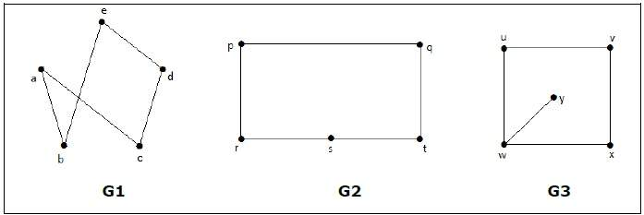

In the graph G3, vertex ‘w’ has only degree 3, whereas all the other graph vertices has degree 2. Hence G3 not isomorphic to G1 or G2.

Taking complements of G1 and G2, we have −

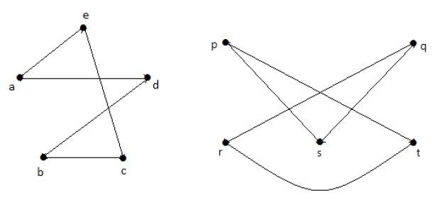

Here, (*G1−* ≡ *G2−*), hence (G1 ≡ G2).

**Example-1**

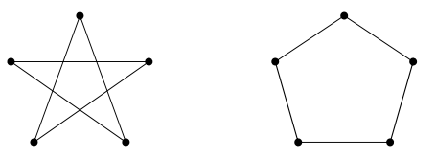

Firstly, label the graphs. It “looks” true, so check all the things we know:

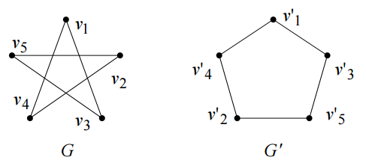

Number of vertices : both 5.

Number of edges : both 5.

Degrees of corresponding vertices : all degree 2.

Connectedness : Each is fully connected.

Number of connected components : Both 1.

Pairs of connected vertices : All correspond.

Number of loops : 0.

Number of parallel edges : 0.

Everything is equal and so the graphs are isomorphic.

More formally:

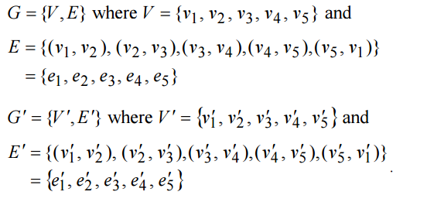

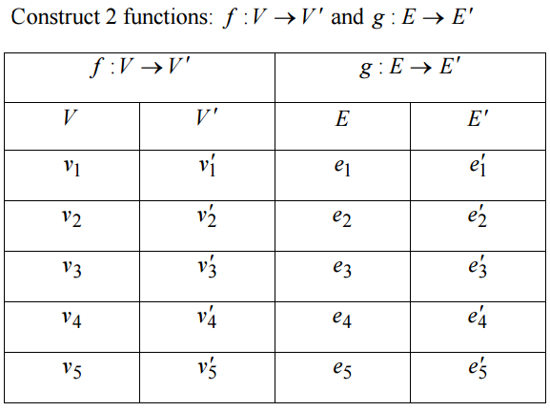

**Example-2**

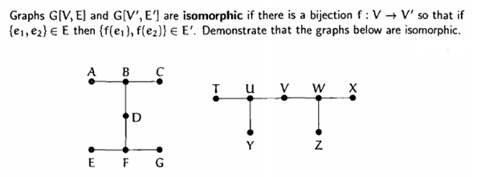

It is isomorphic as the Number of vertices on both graphs are 6 and the number of edges on both of the graphs are both 7.

Degree of nodes:

Deg (A) = 1 and Degree (T) = 1

Deg (B) = 3 and Degree (U) = 3

Deg (C) = 1 and Degree (Y) = 1

Deg (D) = 2 and Degree (V) = 2

Deg (E) = 1 and Degree (Z) = 1

Deg (F) = 3 and Degree (W) = 3

Deg (G) = 1 and Degree (X) = 1

**Example 3.**

As an easy example, suppose we want to show that these two graphs are isomorphic.

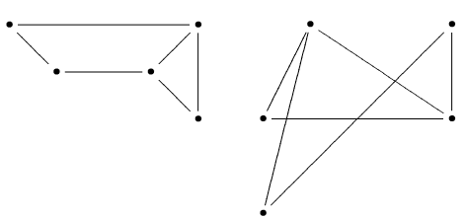

In each case the degree sequence is (2,2,2,3,3) so we might expect that there is an isomorphism.

First we put labels “A” and “B” on the two degree-3 vertices. There is more than one way to do this, so we guess and hope.

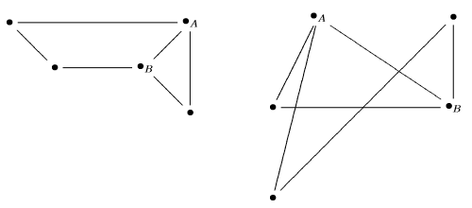

Notice that in both graphs, there is one vertex that connects to both A and B, so lets label that “C ” in both graphs:

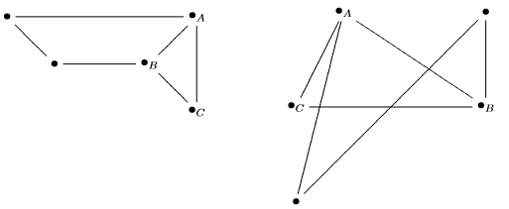

Now notice that in both graphs, there is a path from A to B through the two unlabeled vertices. Let’s label them “D ” and “E ” where D is the one adjacent to A :

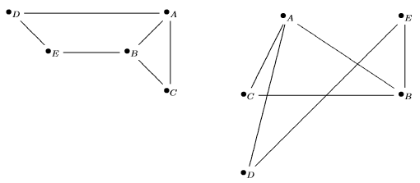

To verify that this determines an isomorphism, we need to check the list of edges. Doing this by determining the list of vertices adjacent to each vertex:

A is adjacent to: B,C,D

B is adjacent to: A,C,E

C is adjacent to: A,B

D is adjacent to: A,E

E is adjacent to: B,D

**Problem 4:** Show that the following two graphs are isomorphic.

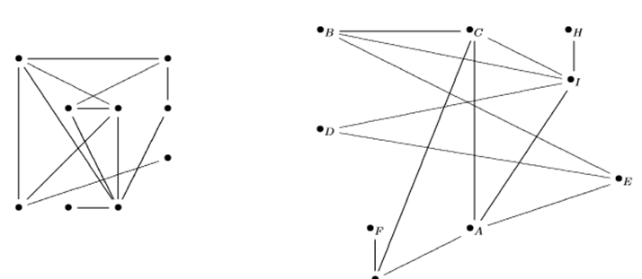

**B. Not Isomorphic**

**Example-1:** Consider the following graphs, are they the isomorphic, i.e. the “same”?

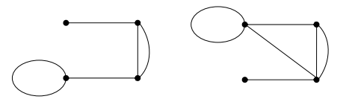

No. The left-hand graph has 5 edges; the right hand graph has 6 edges.

**Example 2:** Suppose we want to show that the following graphs are not isomorphic.

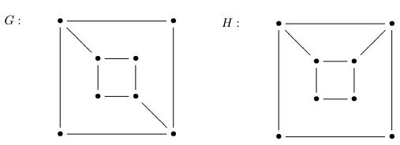

In each graph, there are four vertices of degree 2 and four of degree 3. It is helpful to mark these, so let’s circle the vertices of degree 3.

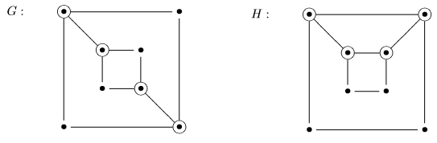

In H, the degree-3 vertices form a 4-cycle (a,b,c,d),

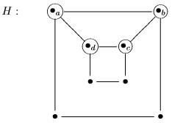

so we would need to label the four degree-3 vertices in G so as to form a 4-cyle. However, we cannot, as the vertices x and y are not adjacent to z and w :

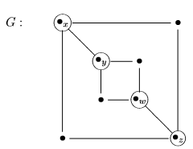

Therefore, there is no isomorphism of G with H.

**Questions 1.** Show the following two graphs are not isomorphic.

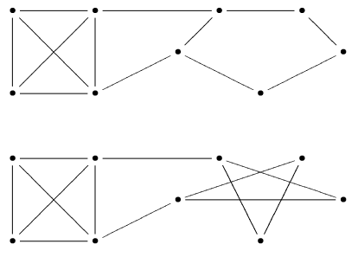

**Questions 2.** Show the following two graphs are isomorphic.

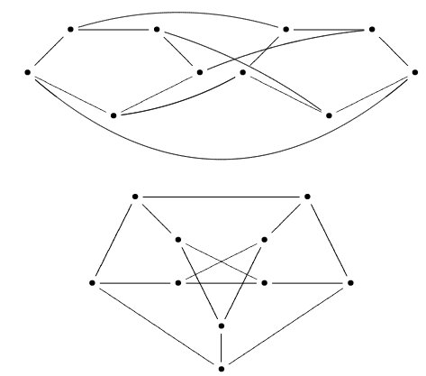

### Homomorphism

Two graphs G1 and G2 are said to be homomorphic, if each of these graphs can be obtained from the same graph ‘G’ by dividing some edges of G with more vertices. Take a look at the following example −

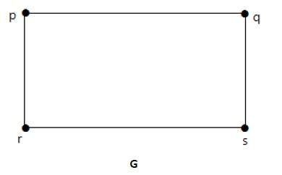

Divide the edge ‘rs’ into two edges by adding one vertex.

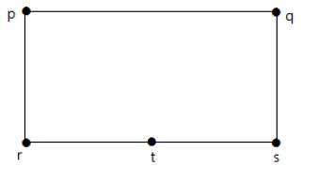

The graphs shown below are homomorphic to the first graph.

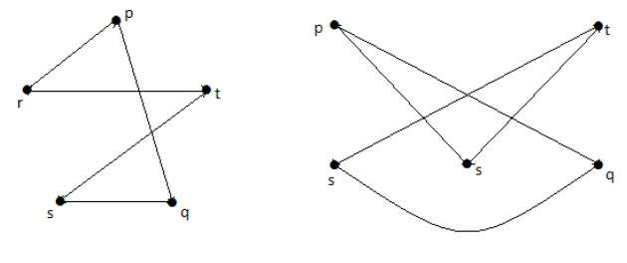

If G1 is isomorphic to G2, then G is homeomorphic to G2 but the converse need not be true.

* Any graph with 4 or less vertices is planar.
* Any graph with 8 or less edges is planar.
* A complete graph Kn is planar if and only if n ≤ 4.
* The complete bipartite graph Km, n is planar if and only if m ≤ 2 or n ≤ 2.
* A simple non-planar graph with minimum number of vertices is the complete graph K5.
* The simple non-planar graph with minimum number of edges is K3, 3.

**Planar Graph**

A planar graph is a graph whose lines are drawn in any plane with simple plain lines keeping in view that the vertexes or edges of the graph do not intersect or cross any other’s vertex.

The number of graph crossing is always zero in a planar graph. This means not even one edge out of the whole graph’s edges can intersect or cross any other’s edge.

The vertexes or a node of a planar graph is generally denoted by v or n respectively.

**For example:**

The planar graph with vertex as = 1, that is, the graph with the number of vertex as equal to zero, is shown as below:

  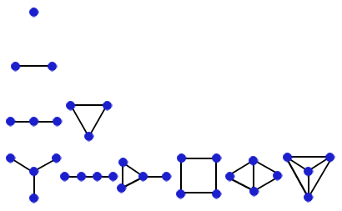  
 

Similarly, we can see that the planar graphs with the number of vertexes equal to 2, or 3 or 4, can be drawn as shown above. Note that all of the above graphs are planar, as none of them have any two edges crossing any one edge.

A graph G = (v, e) (as vertices and edges) is a drawing which maps each vertex u belonging to v to a point e(u) in a two dimensional space, and it’s a mapping of each edge ux belonging to e, making a path with its end points as e(u) and e (x). This graph is a planar graph if it can be made without any crossing over its edges.

Thus, a planar graph G, which is embedded in a plane, divides the pane into some different spaces, which is known as the faces of G. we denote the number of vertices of a graph G by v, the number of edges of a graph G by e and the number of faces of a graph G by f.

**Some of the examples of planar graphs are the graph of**

**a)** a tetrahedron, denoted as K4,   
**b)** the graph of K2, 5, and   
**c)**a cube, denoted as Q3, whose graph are shown as below:

* 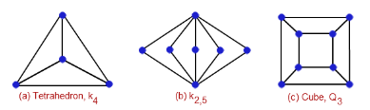

These are the most important examples of a planar graph as they are used for solving other complex problems base on planar graph theory.  
  
A non planar graph is a graph, which can have any number of crossed edges with each other. 

**For example:**

The following are some of the examples of non planar graphs:

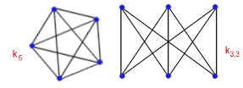

Note that the above two non planar graphs make the core or base for the planar graph theory as many properties and theorems depends on the above two non planar graphs. Hence, it is very much required to understand in great depth about the structure and drawing of these above two non planar graphs.   
  
**Some of the other higher order examples of planar graphs like:**

a) a octahedron (has 8 faces, 6 vertices and 12 edges).  
b) a dodecahedron (**has 12 faces, 20 vertices and 30 edges).**  
c) an icosahedron (20 faces, 12 vertices and 30 edges).

are shown as below:

